**An Innovative Approach to Mitigate the Spread of Diseases in the Airport**

**Team Members:**

**Hunter Schuler (Undergraduate),**

**Melaine Sit (Undergraduate),**

**Edgar Ryan (Undergraduate),**

**Steven Zeng (Undergraduate),**

**James Flaherty (Undergraduate)**

**Advisor: Paul Meister**

**The Pennsylvania State University**

# Executive Summary

While disease propagation and spread does not directly affect airline operations, any extent of it will involve proportional negative consequences, whether it be in terms of health, business, or reputation. Mitigation of disease spread is both an effective measure to safeguard public health within the airport and across borders and an underlying factor in airport commerce. This is especially the case in modern times, as both the SARS outbreak and spread of COVID-19 occurred only years prior. The Federal Aviation Administration currently promotes the adherence to a Best Practices Manual for gateway airports to combat against contagious diseases (Jordan, 2005). However, attention towards the airport’s role in disease propagation is often overwritten by efforts towards its counterpart, the plane. It is also widely accepted that airports can only play a supportive role in mitigating disease spread – instead, the risk lies “primarily with the local, regional, or national public health authorities” (Willis, 2020). While acknowledging the airport’s limited capacity in this subject, the proposed system targets airport infrastructure by manipulating internal airflow with minimum hardware expense to control the spread of airborne particles, consequently limiting the spread of airborne disease within airport establishments.

The following proposal introduces a complete description of a novel HVAC system within an innovative approach towards disease mitigation, and includes risk, cost, and sustainability assessments. The design team’s background encompasses mechanical physics, aerospace engineering, computer science, and mechanical engineering technologies. Industry experts in airport management, airline supervision, along with academic experts in engineering and physics were consulted throughout the system design and analysis process.

# Table of Contents

[1. Executive Summary 1](bookmark://_Toc58968105#_Toc58968105)

[2. Table of Contents 2](bookmark://_Toc58968106#_Toc58968106)

[3. Problem Statement 3](bookmark://_Toc58968107#_Toc58968107)

[3.1 Analysis of Stakeholders 4](bookmark://_Toc58968108#_Toc58968108)

[4. Summary of Literature 5](bookmark://_Toc58968109#_Toc58968109)

[4.1 The dirtiest places in the airport 5](bookmark://_Toc58968110#_Toc58968110)

[4.2 Microbial lifespan on various surfaces 5](bookmark://_Toc58968111#_Toc58968111)

[4.3 Pandemic spread through varying climates 6](bookmark://_Toc58968112#_Toc58968112)

[4.4 The effects of proper ventilation on particle spread 7](bookmark://_Toc58968113#_Toc58968113)

[4.5 Airport green cleaning protocols 9](bookmark://_Toc58968114#_Toc58968114)

[4.6 Viability of rapid testing 10](bookmark://_Toc58968115#_Toc58968115)

[4.7 Previous efforts and recommended actions 10](bookmark://_Toc58968116#_Toc58968116)

[4.8 Public opinion on potential solutions 11](bookmark://_Toc58968117#_Toc58968117)

[5. Problem Solving Approach 12](bookmark://_Toc58968118#_Toc58968118)

[5.1 Solution Matrix 13](bookmark://_Toc58968119#_Toc58968119)

[5.2 Safety Risk Assessment 14](bookmark://_Toc58968120#_Toc58968120)

[6. Description of Technical Design 16](bookmark://_Toc58968121#_Toc58968121)

[7. Description of Interactions with Industry Experts 18](bookmark://_Toc58968122#_Toc58968122)

[7.1 Point of View 21](bookmark://_Toc58968123#_Toc58968123)

[8. Projected Impact 21](bookmark://_Toc58968124#_Toc58968124)

[8.1 How This Project Meets ACRP Goals 21](bookmark://_Toc58968125#_Toc58968125)

[8.2 Sustainability Assessment 21](bookmark://_Toc58968126#_Toc58968126)

[9. Conclusion 25](bookmark://_Toc58968127#_Toc58968127)

[10. Appendix B 28](bookmark://_Toc58968128#_Toc58968128)

[11. Appendix D 29](bookmark://_Toc58968129#_Toc58968129)

[12. Appendix E 31](bookmark://_Toc58968130#_Toc58968130)

[13. Appendix F 35](bookmark://_Toc58968131#_Toc58968131)

# Problem Statement

Airports are a vital part of a modern country’s travel infrastructure. They allow people to move across large distances quickly and easily for business and pleasure. Due to this vital importance of airports, the Airport Cooperative Research Program (ACRP) has requested that college students around the country work to improve key technical challenges airports face. Our team has drafted a model targeting the airport environment, specifically helping to contain and control the spread of disease through airports. We chose this in response to the COVID-19 pandemic, hoping to slow the spread of future outbreaks as well as increase the health standards of airports in the future. According to the TSA, the total throughput for this year versus previous year is about 65% lower, as shown in figure 1.

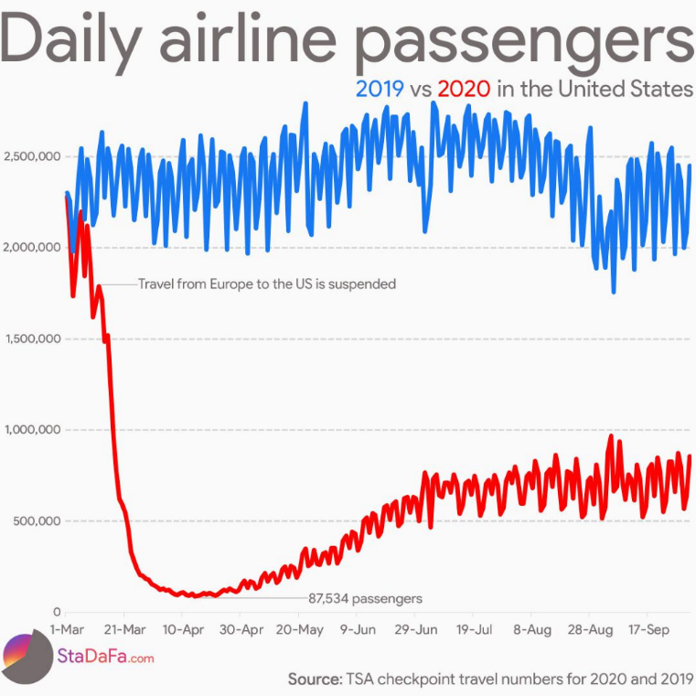

*Figure 1.* Visualization of decreases in travel from April 10th to present day.

The United States Department of Transportation reported that USA airlines had 925.25 million passengers in 2019 (U.S. DOT, 2019); that is over 2.5 million per day. With that many people moving through our airports, there is a large potential for the propagation of diseases. With the ability to travel to almost any city in the world through air travel, diseases can easily spread at worrying rates. According to the TSA, on a single Sunday in September during the current COVID-19 pandemic, over 809,000 Americans traveled through domestic airports (TSA, 2020). While sanitation measures have been increased during the pandemic, to truly stop the spread of diseases, additional steps need to be taken.

In this report, the proposed technology will operate under the following procedures:

1. Model abstraction and distribution will only apply towards airport gateways, terminals, and other establishments.
2. Air flow and metrics will be analyzed using SolidWorks model simulations according to chosen designs.
3. The impact on disease spread will be calculated using the Wells-Riley Equation.

## 3.1 Analysis of Stakeholders

Our team began by identifying and researching stakeholders to determine exactly who our airport sanitation project would be affecting.  We determined that there were four main stakeholders in airports when regarding the matter.  The first, and largest, is the passengers themselves. They spend money in the airport on tickets, services, and concessions. David Schaar, leader in the Transportation and Logistics topic at Boston Consulting Group, says “passengers can be viewed as individual travelers that have expectations about receiving quality services, and passing through the airport system in a convenient manner” (Schaar). That is why the goal of airports is to move passengers through quickly in a convenient and cost-effective manner.  If this is not achieved, the passengers will be less likely to travel. The next important stakeholder is the airlines themselves.  Air carriers select airports based on the passenger demand for service to and from the airports and on the cost of operating at the airport (Schaar).  Lower cost makes the airport more attractive to airlines, therefore, ensuring that passengers are passing through in a timely matter is important. The airport should act as an efficient hub and connection point, contributing to ensuring air carriers on time performance (Pat Oldfield, United Airlines 2009). The last stakeholders our team identified are the businesses and retail stores inside the airport itself. They usually pay the airport a fixed annual fee, as well as a percentage of their earnings (Wells & Young 2003; p. 324).  The main goal of the concessionaires is to maximize profits, so they seek airports with maximum passenger volume and minimum fees to the airport. With all these taken into consideration, it is clear the main goal of the airport is to run as efficiently as possible.  That is why our solution for minimizing disease spread needs to be both cost effective and time effective.  If it is too expensive or causes too much delay in airport operations, then it will have a negative effect on the stakeholders. This could result in a decrease in airport travel volume as well as less incentives for airlines, concessionaires, and services to do business with the airport.

# Summary of Literature

## 4.1 The dirtiest places in the airport

To design a solution for the challenge, we started with identifying where in the airport were high touch areas. Researchers from University of Nottingham and the Finnish National Institute for Health and Welfare found that the self-check in kiosk, children’s playgrounds, and security bins at the TSA security check point were the were the most susceptible to having more than one respiratory virus on their surface. The most common viruses that were identified on those surfaces were Rhino virus, Coronavirus, and Adenovirus (BMC, 2018). The amount of high touch areas varies on the traffic of the airport and how well implemented the cleaning protocol is.

## 4.2 Microbial lifespan on various surfaces

Germs have different survival rates depending on the germ and which surfaces they are on. Dr. James M. Steckelberg states that viruses do not remain as long on fabric and soft surfaces as harder surfaces (Mayo, 2020). In fact, Larrouy-Maumus, who is an infectious researcher at Imperial College London in UK, reports that viruses such as COVID-19 can remain active on hard surfaces, such as plastic and stainless steel, for up to three days. However, Larrouy-Maumus states that the ions in copper alloy can kill over 99.9% of bacteria within two hours (BBC, 2020). Although this would help decrease the transmission rate in high touch areas, the downsides to implementing copper in the airports is that it is expensive and difficult to clean without it corroding.

Elena Inanova, a researcher at RMIT University in Australia, has been researching the texture of cicada wings which has “tiny spikes on the surface” that does not allow bacteria to settle and grow on their wings (BBC, 2020). They want to implement this feature into graphene sheets and incorporate it onto high touch surfaces. Researchers would like to enhance the sheets by making the tiny spikes sharper so that it can rupture the bacterial membrane, but minute enough to not damage hand skin. As effective as this could be, it would require the airport to resurface high touch areas.

## 4.3 Pandemic spread through varying climates

After the influenza outbreak in 2013 to 2014, a study was conducted in July of 2014 to attempt to link the climate of the atmosphere in each area where an outbreak occurred (NIH, 2014). Though this initial analysis lead to no concrete results, another analysis was done during the COVID-19 pandemic of 2020 (NIH, 2020). In this study, the research team varied the temperature from 0 to 40 C and relative humidity from 0 to 92%. This study also includes different weather conditions from across the United States. This study concluded that aerosolization is maximized in a hot and dry climate, while travel distance is maximized in cold and humid environments, as summarized in figure 1. Along with the results from figure 1, the study concluded that as background wind velocity increases, so does maximum travel distance for droplets.

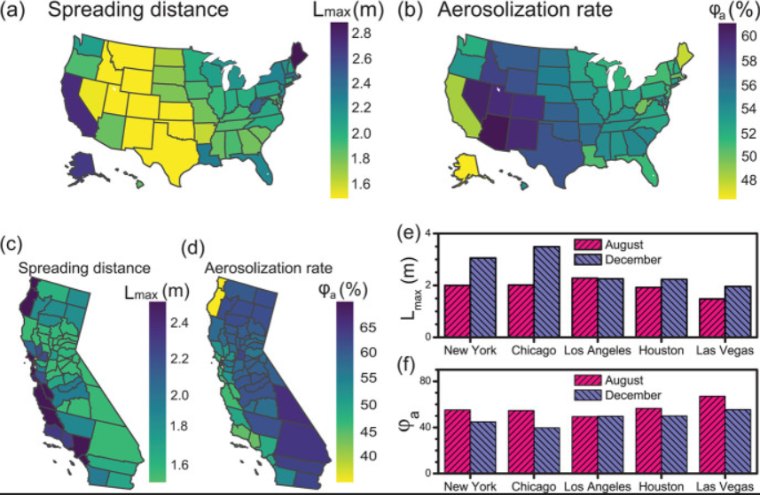

*Figure 2.* Aerosolization and spreading of COVID-19 droplets by state and city

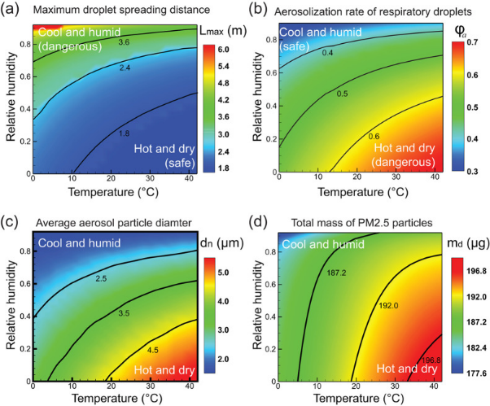

*Figure 1.* Properties of COVID-19 droplets varied by humidity and temperature.

A summary of the data from this study is presented in figure 2. Given the results from figure 2, the travel distance for particles in locations which are colder and more humid, such as the East Coast. The data concluded in figure 1 is also supported by the high aerosolization rate in hot and dry locations, as seen in states such as Utah and Texas, as well as many others in the mid-west.

## 4.4 The effects of proper ventilation on particle spread

Using an analysis of SARS outbreak of 2003 in Hong Kong, the primary cause of infection was improper indoor air ventilation. Airborne transmission mostly occurs in indoor environments, where most people spend 90% of their time. Respiratory droplets containing pathogens are expelled from patients during activities such as sneezing, coughing, speaking, singing, or simply breathing. Ventilation plays a key role in preventing cross infection in indoor environments, as shown by the Wells-Riley Equation, which successfully predicted a measles outbreak in suburban USA, and is commonly used to predicts and study outbreaks.

The Wells-Riley equation is defined as $P=\frac{C}{S}=1-e^{-\frac{Iqpt}{Q}}$ where *P* is the risk of cross infection, *C* is the number of case to develop infection, *S* is the number of the susceptible, *I* is the number of infectors, *p* is the pulmonary ventilation rate of each susceptible (ft3/h), *Q* is the room airflow rate (ft3/h), *q* is the quanta produced by one infector (quanta/h), and *t* is the duration of exposure (h).

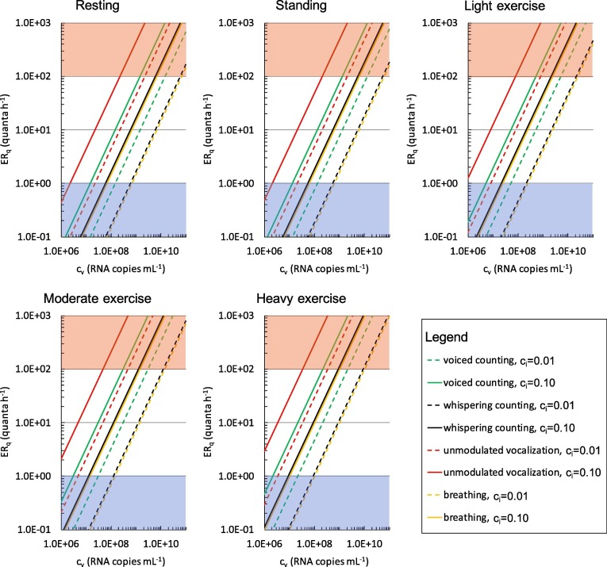

*Figure 1:* ERq (quanta h−1) trends as a function of the viral load in sputum (cv, RNA copies mL−1) and quanta-RNA copies correction factor (ci) for different respiratory activities (voiced counting, whispered counting, unmodulated vocalization, breathing) and different activity levels (resting, standing, light exercise, moderate exercise, and heavy exercise). Zones representative of low (<1 quantum h−1) and high (>100 quanta h−1) quanta emission are indicated as blue and red shaded areas, respectively.

Flow direction is just as important as volumetric flow rate when it comes to preventing the spread of diseases in indoor environments. In hospitals, providing fresh air in operating rooms and air-infected wards is key to preventing any cross contamination. In a downward ventilation environment, droplets penetrate only a short distance and exhaled droplets were quickly diluted. This showed a strong promise in removing exhaled pollutants from the environment (Thorac 2018).

For the SARS-CoV-2 virus, patients have been found with an estimated range of 108-109 RNA copies mL−1, however the concentrations of viral load in the mouth can reach values of 109-1011 RNA copies mL−1. The number of infected quanta released per hour is directly correlated to the infective concentration of the patient (Buonanno, Stabile, Morawska, 2020).

## 4.5 Airport green cleaning protocols

Airports have a specific protocol they need to follow as to how they keep their terminals clean. The biggest factor airports need to take into consideration when designing a protocol is the traffic flow in the terminals. Other smaller factors include the number of available personnel and the complexity of certain areas in an airport, such as children’s playgrounds and massage parlors (WHO, 2009). Airports form their protocols starting with asking bidders “their experience cleaning airports, their management systems, their hiring and training programs, [and] their green cleaning experience and certifications” (Aviation Pros, 2015). Airport facility managers need this information to sort through the strengths and weakness of each bidder. Then the facility managers will discuss with the bidders the expectations that the airport must uphold in order to keep the airport clean. Such details include how many times and when exactly should the floors be cleaned as well as whether the floors be vacuumed or mopped. In addition to these specified requirements, they must embrace green cleaning because airports are a large consumer of cleaning products. The government has “a responsibility to reduce environmental impacts to the community and to save money.” (Aviation Pros, 2015) Therefore, there is a need of specific detail when cleaning to ensure that airports are following green cleaning.

As part of evaluating the vendors, airport facility managers examine if vendors have an effective site manager as well as an excellent training program for their workers. The vendor needs to keep up with innovation and “new equipment designed to make the job more effective and efficient.” (Aviation Pros, 2015) These are just some of the steps that airport facility managers must go through to ensure that the terminals health and sanitation are upheld. Our team will keep this in mind when deciding a solution.

## 4.6 Viability of rapid testing

Rapid tests have been developed over time to test for numerous diseases, both respiratory and not. Of the respiratory rapid tests that have been developed, the main administration method is either throat swab or nasopharyngeal swab. These tests can check for Group A *Streptococcus*, Influenza, Respiratory syncytial virus, and many common viruses and atypical bacteria, whether the passenger is experiencing symptoms or not. The main concern for this approach would be that despite the airport being able to detect any virus, they would not be able prevent any passengers path through the airport or admittance to the airline. Along with this, there is concern on medical clearances and need for laboratory technicians to analyze the results of the tests.

## 4.7 Previous efforts and recommended actions

By looking to the past, we can see what actions have been taken and their effectiveness. This then sets up a baseline for solution brainstorming later. In 2015, scientists implemented the PANDHUB project in select European airports for 3 years. Through trial and error, scientists have identified five key points that serve to mitigate disease spread the most effectively: adequate ventilation to reduce air-borne concentrations (environmental control), exclusion of symptomatic persons (administrative control), separation of international and domestic travelers (administrative control), and measures to reduce indirect contact transmission (administrative and personal control) (Ilpo Kulmala, 2017). By concentrating on these categorical measures, we can begin to brainstorm our own innovative solutions.

## 4.8 Public opinion on potential solutions

To collect more data on habits of people in airports we distributed a survey to as many people as we could and got over a hundred responses. Here we found that a vast majority of the people who responded traveled on average a few times per year before COVID-19 and only a few having not traveled or having traveled more than a few times per month. That had dropped to only 15% afterwards with most of them having only traveled once. However, while the flights taken by people has vastly decreased, the amount of people that still have a need to fly has not dropped nearly as much, with 48% of people still saying they had a need.

When It comes to how sanitary the airport is, many people felt that the airport had gotten cleaner since COVID-19 started, with the amount of people saying that it was “Extremely clean” increasing by 650% and the amount of people saying it was “Somewhat not clean” dropping by 43% [Fig 1]. This is interesting because, while people feel it is cleaner, out of the people that still said the have a need 36% said that part of the reason was sanitation of the airports and 72% said that it was because of other passengers and 57% was due to the airplanes [Fig 2]. On average, people are willing to wait an additionally 28 minutes to help remedy this.

Figure 1

Figure 2

There are of course potential flaws in our data. For one our sample size was relatively small and might not have been as representative as we would have liked due to our method of distributing. Additionally, we did not account for certain factors that might have played a role, such as a change in financial situation due to COVID-19. Lastly, a lot of people responded regarding COVID-19 and not for sanitation.

# Problem Solving Approach

Our problem-solving approach began with identifying and defining the problem. In doing so, adequate research was generated from both online research papers, industrial experts, and distributed surveys. Constraints were then defined collectively by the team as the solution scope was narrowed down to specific categories. Using these specific categories, we utilized a human-centered design approach to create broad themes and distinct insight statements that translated towards brainstorming. Our method was to have team members rotate and provide their themes or insights, before discussing with the group in a friendly and concise manner whether the theme or insight would be valid for our project. Some of the themes we discovered were public compliance, indirect physical contact, and air quality. Using these themes, direct insight statements were created. For example, for the theme of indirect physical contact, a few insights created include the effect of surface material on bacteria/virus lifespan, the use of personal devices to combat shared physical contact, and the use of sanitation to combat virus/bacteria loitering. The brainstorming process centered on brainwriting, where ideas were generated individually before presented to the group. These ideas were then processed and refined by the group and used as launchpads for newer innovative ideas. Finally, the list of more than 10+ ideas underwent an initial ranking to determine which ideas were of higher priority when interviewing industry experts. Some ideas include a TSA bin-washing system, pre-boarding rapid testing, suitcase covers, and kiosk screen protectors. Favored ideas were then reordered based on feasibility and impact.

## 5.1 Solution Matrix

Our solution matrix, shown in figure 1, evaluates each brainstormed idea based on certain criteria we found to be essential. Each criterion has a fixed weight that determines its importance relative to the overall solution. The higher the weight, the greater the impact it will have on the total point system. Then each criterion has a scale from one to ten where ten means it is an ideal solution for that specific criterion. Based off what we scaled it, that number would then be multiplied by its weight and that would be the number of points rewarded for that idea in that criterion. The idea with the highest total points is the most optimal based on the solution matrix.

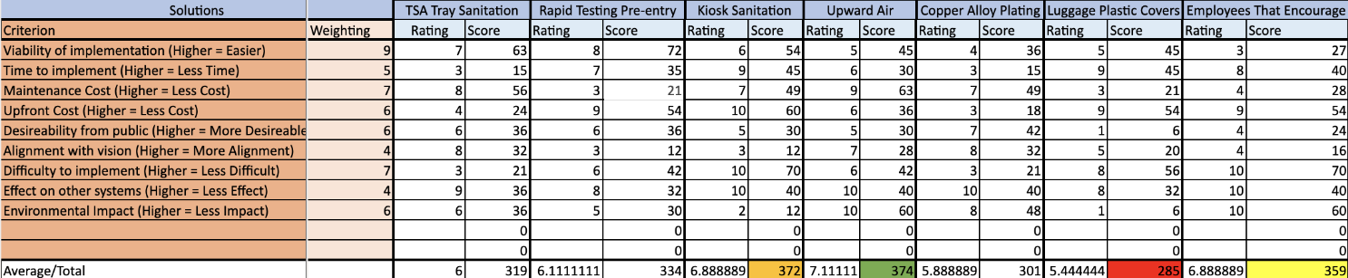

*Figure 1:* Solution matrix showing criteria weighting and idea scores

The criterion that carried a higher weight in points were viability of implementation, long term maintenance cost, and difficulty to implement. We decided that these criterions were the most important factors to consider when determining the most practical idea. The top three ideas based on our criteria were upward air vents, kiosk sanitation, and employees that encouraged. Upward air vents had the highest amount of points and we moved forward with this idea as our solution. We then decided that it would be more feasible to do downward air instead of upward air. We will discuss this in greater detail in the description of technical design.

## 5.2 Safety Risk Assessment

According to the Federal Aviation Administration a comprehensive safety risk assessment identifies hazards, assesses the risk, analyzes the risk, and controls the risk. The FAA recommends doing a risk analysis for all aviation projects and compiling findings into a safety-assessment matrix. Above is the safety-assessment matrix our team developed to treat and categorize risks we identified in our airport’s HVAC system. 10 risks were identified, with 4 being low risk scenarios, 4 being of moderate risk, and then 2 being unacceptable risk. Risk is determined by the likelihood and severity of an event occurring. The FAA says that moderate risk is the minimum accepted objective, with the proposal able to be implemented, but tracking and management are required. Unacceptable risks must be mitigated to at least moderate. We identified one of our most severe risks to be poor air circulation due to system failure. To accommodate and mitigate the risk, our team chose to schedule quarterly maintenance as well as specialty checkups to ensure our system is running smoothly and the risk is properly mitigated. This greatly decreased the likelihood of it happening to extremely improbable. Another severe risk our team identified was the possibility of our solution failing as a result of real-world variables not accounted for in our simulations. This would mainly be due to a high volume of moving people. The large number of travelers would likely disrupt airflow and cause our system to not behave as it would under ideal conditions. The best way to mitigate this risk, we found, would be to run more extensive simulations to account for other variables such as passenger volume and movement. These extra tests would require more research and be more expensive, but the best way to ensure our system behaves correctly under all conditions. With this being done we were able to mitigate this risk to extremely improbable. Overall, our system exhibits relatively low risk, with all of our unacceptable risks successfully mitigated to moderate, and many of our moderate risks able to be mitigated to low risk. Below are two tables the list out our identified risks, which are categorized by severity and probability. Acceptable risks are in green, moderate risk is in yellow, and unacceptable in red. Each identified risk in Figures 1 and 2 have a corresponding number that was placed in the actual risk-assessment matrix in Figure 3.

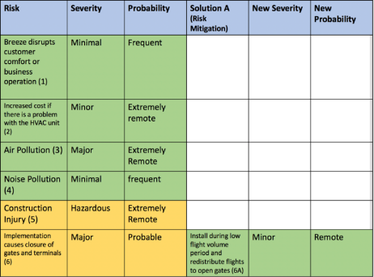

*Figure 1: Identified risks w/ severity and probability*

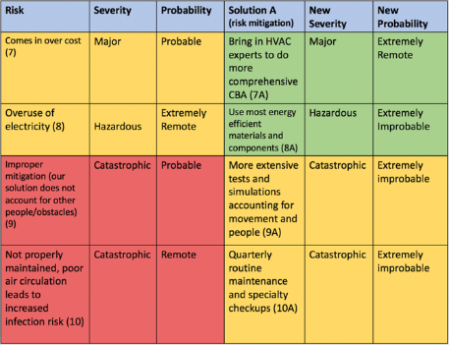

*Figure 2: Identified risks w/ severity, probability and mitigated risk*

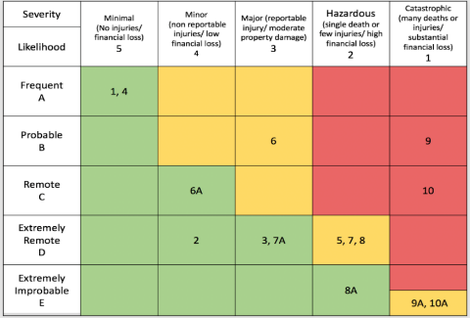

*Figure 3: Risk Assessment matrix with green being acceptable risk, yellow moderate risk, and red unacceptable risk*

# Description of Technical Design

Why do facemasks work? The CDC conducted studies to show that air droplets from exhalation are caught by the mask as to mitigate contamination of the surrounding area. Ventilation comes in afterward – a dead zone, where there is no air flow, allows particles to potentially drift for long periods of time in space. An airflow system, however, allows for suction of these airdrops into an HVAC system where further filtration and purification can be done. Research into different ventilation systems showed this design, to be among the most effective in mitigating the spread of disease.

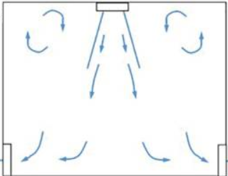

*Figure 1:* Design for downward blowing air to mitigate disease spread

This model is considered ideal as it provides fresh air in operating rooms and air-infected wards is key to preventing any cross contamination. In a downward ventilation environment, droplets penetrate only a short distance and exhaled droplets were quickly diluted. This showed a strong promise in removing exhaled pollutants from the environment.

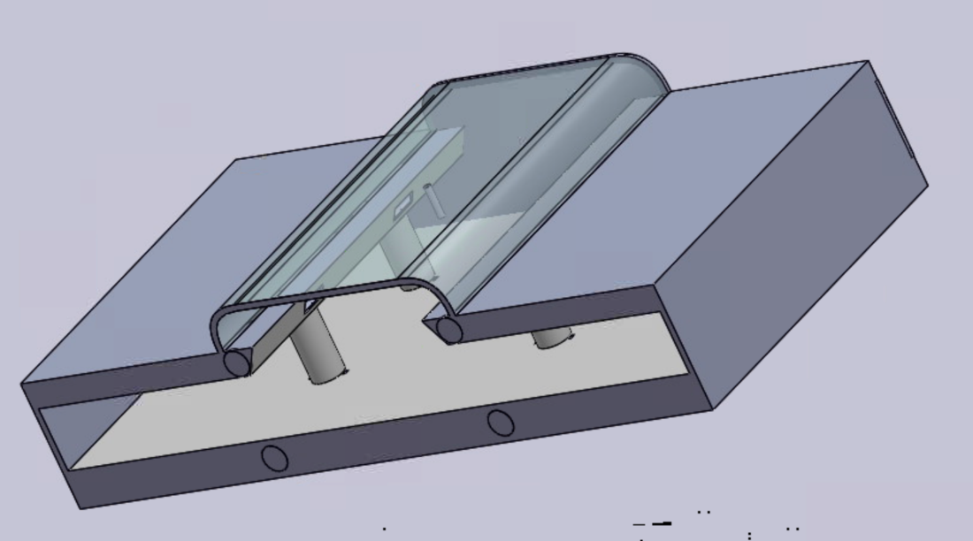

*Figure 2:* Incomplete preliminary airport cross section design of gate and terminal

A current ideal model is proposed by utilizing Solidworks technology to create a three-dimensional Computer Aided Drafting (3D CAD) Model (show in figure 2) which allows full implementation of a downward ventilation environment using specific tunings such as diagonal vents, optimized floor layouts, and air tunnel control.

This model implements the solution discussed from figure 1 in both the main terminal hallway and within the gate areas. Within the terminal, angled vents blow downward toward the main hallway and a fan will push the air down, further accelerating it. There are four 5ft x 2ft rectangular vents pushing air into our system at a velocity of 10ft/s above the main terminal. Along the floor of our terminal there are 10 2ft x1ft rectangular vents sucking air out of our system at a rate of 20ft/s. Above the gates there are 4 circular vents, each with diameter of 4ft, putting air into our system at 10ft/s. These can be found on either side of thee gates so there are 8 ceiling vents in total. On the floor, we have 24 1ft x1.5ft rectangular vents (48 in total) sucking air out our system at 18ft/s. Additionally, we have 2 1ft x 5ft rectangular vents (4 in total) located near the walls, taking air out of our system at a rate of 18ft/s. This makes the volumetric flow rate (vent area x air velocity) into our system, equal to the flow rate out of our system. This allows for the best laminar flow and flow rate to circulate out virus particles and provide a minimal infection risk.

An example of a visual analysis within the ideal model was obtained as figure 3, which shows the air speed as a vector in each location. This assures that each space in the airport can maintain proper air speed to mitigate virus spread from passengers.



*Figure 3*

Since the proposed approach is intended to mitigate transfer of “used” air between passengers, the raw data will be filtered into the Wells-Riley equation, which utilizes the proportion of infected subjects, infector quanta, pulmonary ventilation rate, duration of exposure, and room airflow magnitude to calculate the risk of cross-infection.

# Description of Interactions with Industry Experts

During our research phase, we met with Roger Studenski, the Risk and Safety Manager for the Jacksonville Airport. We conducted an interview with him pertaining to the actions his airport has taken during the COVID-19 crisis. Roger believes that despite the publics fear, the airport could still maintain operations at maximum capacity while maintaining public safety.

Some of the procedures implemented in the Jacksonville airport include treating high contact areas with disinfectant and even shutting areas to “fog” them. Jacksonville airport has also been providing hand sanitizer and masks to passenger who need them or want extra. Along with this, Jacksonville has also been ensuring employee safety by mandating employee wear masks and have their temperatures taken before work.

When asked on what could still be improved, Roger said that the only thing that can be better is there throughput. He is hoping the air carriers can convince more people to travel in order to improve their customer base, and thus throughput. He would also like to see more passengers wear masks during a pandemic, as well as not travel if they are knowingly sick as this poses a risk to all other passengers. The only thing Roger said that could not change would be to follow FAA guidelines and procedures to not fall into trouble with the law.

Roger stated that an optimal solution would be one which can prevent the airports from operating at reduced revenue as they have during the COVID pandemic, while also supporting the trust of fliers. The main cause of the reduced revenue is the fact that the airports cannot reduce any of their operations, including cleaning, sanitization, tarmac maintenance, ticketing, and concessions inside the airport.

Roger believes that passengers may be more willing to accept changes based on how the government agencies, such as the CDC, respond to whatever outbreak there may be. This include if a long-term solution is implemented and the CDC claims it is safe to travel, that passenger will feel more at ease during travel, and thus more willing to travel.

During our solution brainstorming phase, our team also conducted an interview with Al Berti, a United Airlines pilot who flies out of Newark. Airports and airlines to some extent operate independently, having different protocols and procedures when it comes to health and safety. Al was very helpful in laying out procedures specific to airlines. He informed us of United starting a rapid COVID-19 testing program at the San Francisco airport to identify disease carriers before they board the plane. The airlines can then deny that person entry to the flight. This was one of the solutions our group has come up with to implement.

Al also believes that airports post COVID are much cleaner than previously, and that the airports and airlines are now taking precautions that they should have been doing long before. Airline employees are required to have their temperature taken twice daily, and all passengers are required to wear a mask. Otherwise, the plane will not take off. He also noted a substantial improvement in airport cleanliness and sanitation as opposed to pre-COVID.

One concern he highlighted however was that of flight turnaround time. Airlines look to minimize flight turnaround time in order to increase their revenue margins, and increased time on the ground is likely with new sanitation and testing procedures. According to Al, turnaround time can range anywhere from twenty-five minutes to one hour, and said that with new airport safety precautions it would tend to be closer to an hour. He was in full support of rapid testing at the gate and thought it would be an excellent safety measure for all airports and airlines to adopt. Al said that even though it will increase flight turnaround time, it will increase cleanliness and sanitation, as well as make passengers more comfortable with flying. This last point is one he thought would make a large difference. Airlines are not operating at full capacity currently, due to public fear of the virus. Rapid testing at the gate would make the public more comfortable and more inclined to fly. This would in-turn would increase revenue for the airlines and airports. Ultimately, with this solution, Al believes all parties would benefit.

## 7.1 Point of View

We met Roger Studenski, the Risk and Safety Manager at Jacksonville Airport in Florida. We were surprised to learn that he felt the airport could operate at maximum capacity safely, despite the changes surrounding the COVID-19 virus. It would be industry changing if we could devise a solution to increase safety and trust from passengers in travelling during a pandemic to maximize throughput.

# Projected Impact

## 8.1 How This Project Meets ACRP Goals

Assessing people’s interactions with each other and surfaces in the airport is part of the ACRP’s goal of mitigating the spread of diseases in the airport. Through our renovated HVAC system, it helps control the spread of diseases at airports by focusing on the range of water droplets when people talk or cough. With the air acting as a shield around people, it reduces the chance of spreading sickness around the airport, thus meeting the ACRP’s goal.

## 8.2 Sustainability Assessment

The proposed HVAC system approach is designed to mitigate the spread of diseases while not interfering with travelers in the airport. The airport and stakeholders would benefit from our design from the economic, social, and health perspectives. The downside is the environmental impact, but this can be resolved if the airport has a renewable energy source.

**8.3 Economic Impact**

The newly designed HVAC system can create a fail-safe system where the airports will not have to decrease the number of travelers in a time of a pandemic. Therefore, the airport should not lose revenue in case another pandemic or flu season arises. Additionally, it can help airports recover financially from the COVID-19 pandemic and increase the revenue to the same rate as before. There will be an increase of cost due to more energy being used to circulate more air in the airport. However, the increased revenue from the travelers will outweigh the costs of the increased electricity bill.

**8.4 Environmental Impact**

The increased air circulation in the airport will increase the airport’s electricity usage. Since our HVAC solution is an open system, it will be recycling air from the inside as well as taking air from outside and sterilizing it under a UV light to push back into the airport. It will not be necessary to increase the number of UV lights, only the energy to circulate the air constantly will increase. This will leave a larger carbon footprint, unless the airport already has a system for renewable energy. The air quality of the airport itself will be cleaner.

**8.5 Social and Health Impact**

After our team’s HVAC solution system is implemented, we hope to see airports informing their travelers of the new changes which demonstrates the airport’s focus on health. This will hopefully encourage travelers to resume their regular travels without the fear of getting sick. The HVAC system will help restore faith in travelers that the airport is taking further measures to mitigate the spread of diseases during a pandemic as well prevent a future one.

**8.6 Cost Benefit Analysis**

We have completed a comprehensive cost-benefit analysis. As shown in table A, we logged a total of 150 hours towards research and development, assuming a payroll of the average intern. Two members also utilized SolidWorks software.



Based on our CAD Model, we calculated expenditure of both labor and physical materials needed to complete our prototype in table B. Marketing and installation labor rates were taken from statistical averages while materials were referenced off the cheapest prices on the current market.



As our model utilizes a complete HVAC system, it was necessary to introduce maintenance fees, including energy costs as well as labor costs. In table C, prices were referenced off current job listings and electricity costs were calculated with average electricity costs and data on energy conversion rates. These electricity costs were then referenced off our model.



In tables D and E, we worked with calculated risks and potential. Table D shows the cost or benefit any given event would entail. Price tags were calculated based on ratings by the USA Office of Management and Budget along with statistical averages. Airlines are charged rates to land and occupy terminals, which is often taken out of an airline fare. Similarly, this principle also applies towards concessions and other services located within the airport. Table E matches up each item with its potential possibilities. These were calculated on the statistical average years an HVAC unit lasts, COVID rates combined with the Wells-Riley equation using our model’s parameters, and passenger survey rates.





Tables F and G combine the previous tables into a comprehensive physical cost summary and risk cost/benefit summary.





Finally, table H holds our final cost-benefit analysis. The final result is a 78 benefit to cost ratio, mainly reached by the value of lives potentially saved by our prototype.



# Conclusion

In this design project, the proposed cost-effective HVAC system based on air flow conceptuals is presented for the topic “Innovative approaches to help contain and control the spread of disease at Airports”, which is under the section “Airport Environmental Interactions Challenges” of the 2020-2021 Airport Cooperative Research Program University Design Competition for Addressing Airport Needs. By controlling airflow such that a minimal amount of air is recirculated within any given area before suction into a filtration device within an HVAC system, the likelihood of disease spread is lowered. Analyzation of room models and layouts can be done utilizing a SolidWorks 3D simulation. Calculation of a relatively accurate effect on disease spread can be verified by the Wells-Riley Equation.

Details of the theories, practicalities, risks, and cost-benefit are also included in this project report. The results suggest that the proposed project will be financially available to the maximum for new airports, or those in constrution/modification. Further costs can be accumulated by current airports undergoing business operations, but final results of potential benefits suggest airport managers and stakeholders will benefit from the implementation in both revenue, reputation, and public safety. Controlling safe airflow within airports via previously modeled HVAC and area layouts will drastically mitigate the spread of disease in both an innovative and effective manner.

Appendix A

Faculty Advisor:

Paul Meister, P.E.

School of Engineering Design, Technology and Professional Programs

The Pennsylvania State University

213 Hammond Building, University Park, PA, 16802

pmm123@psu.edu

814-865-3368

Students:

Edgar C. Ryan

School of Aerospace Engineering

The Pennsylvania State University

521 Ramblewood Drive, Bryn Mawr, PA, 19010

[ecr5297@psu.edu](mailto:ecr5297@psu.edu)

484-401-2343

Steven L. Zeng

College of Engineering

The Pennsylvania State University

1068 Redtail Road, Norristown, PA, 19403

[slz5121@psu.edu](mailto:slz5121@psu.edu)

908-635-2487

Hunter Schuler

College of Engineering and Eberly College of Science

The Pennsylvania State University

2988 Taylor Drive, Center Valley, PA, 18034

[hzs143@psu.edu](mailto:hzs143@psu.edu)

610-360-2551

Melaine Sit

College of Engineering

The Pennsylvania State University

5755 Meadows Del Mar, San Diego, CA, 92130

mms6909@psu.edu

858-750-8532

James T. Flaherty

College of Engineering

The Pennsylvania State University

36 Rachel Rd, Pleasant Valley, NY, 12569

jtf5322@psu.edu

845-475-4985

# Appendix B

Penn State University is an institution of higher education in Pennsylvania.  It houses the college of engineering which includes numerous engineering degrees at both the undergraduate and graduate levels.  The college of engineering supports an undergraduate minor in engineering leadership in which undergraduate engineers can build the non-technical skills to support the great technical skills they are developing through their engineering curriculum.  The engineering leadership development program offers students classes in project management, leadership education and development, business basics, and cross-cultural teaming.  Students in the minor are dedicated to building these skills in addition to the technical workload required of their discipline's curriculum.  The engineering leadership program also offers a graduate program in the form of a Master of Engineering and an online graduate certificate in Engineering Leadership and Innovation Management.

# Appendix D

Airport Cooperative Research Program

University Design Competition for Addressing Airport Needs

Design Submission Form (Appendix D)

*Note:* This form should be included as Appendix D in the submitted PDF of the design package. The original with signatures must be sent along with the required print copy of the design.

University ___Penn State University_______________________________________________

List other partnering universities if appropriate: _______________________________________ ____________________________________________________________________________

Design Developed by: Individual Student. **X** Student Team

***If individual student:***

Name _______________________________________________________________________ Permanent Mailing Address _____________________________________________________ ____________________________________________________________________________

Permanent Phone Number _________________________ Email ________________________

***If student team:***

Student Team Lead: _____Edgar Ryan_____________________________________________

Permanent Mailing Address __521 Ramblewood Drive, Bryn Mawr, PA, 19010______________ ____________________________________________________________________________ Permanent Phone Number _+1-(484)-401-2343_________ Email _ecr5297@psu.edu_______

Competition Design Challenge Addressed: _3-J: Innovative approaches to help contain and control the spread of disease at Airports.____________________________________________________ ____________________________________________________________________________

I certify that I served as the Faculty Advisor for the work presented in this Design submission and that the work was done by the student participant(s).

___________________ Date___December 1, 2020______

Name ___Paul Meister__________________________________________________________ University/College__Penn State University__________________________________________

Department(s) _School of Design, Technology, & Professional Programs; Engineering Leadership Program____

Street Address _213 Hammond Building____________________________________________ City __University Park________________________ State __PA__ZIP code__16802________ Telephone _814-863-5728____________________________ Fax _______________________

# Appendix E

**Students**

1. Did the Airport Cooperative Research Program (ACRP) University Design Competition for Addressing Airports Needs provide a meaningful learning experience for you? Why or why not?

Yes, the ACRP Competition gave us a meaningful learning experience of how to lead and develop an engineering project while collaborating with our peers. We learned valuable skills on forming and developing a team to engage in creating a solution to a real-world problem. We collaborated with experts in various fields and took advice from many resources to assist in developing our solution to assist in the mitigation of the spread of diseases in an airport environment.

1. What challenges did you and/or your team encounter in undertaking the competition? How did you overcome them?

Our main challenge, due to the circumstances of the year, was coordinating our efforts to complete the project. Due to the COVID-19 virus, we were not able to meet in person with one another to work in a standard face-to-face environment, so instead we utilized technology to work around this. Creating a central repository for our work in Microsoft Teams assisted the team in locating documents and creating a group organization standard for finding everything we need, such as research, work allocations, or prototype information. Additionally, we utilized a group chat to be able to remind each other when things are due or completed, as well as seek advice from one another, when needed.

1. Describe the process you or your team used for developing your hypothesis.

Our team first chose to develop ways to limit the spread of disease and viruses through airports because of the current state of air travel with COVID-19. We thought that a comprehensive solution would be extremely valuable should our world face another pandemic of this magnitude. It would allow for air travel to continue without major drop off in passenger volume like we have seen with COVID-19. Our team started by doing research and brainstorming different solutions on how to address cleanliness of airport facilities and background information on viruses. After we had concluded our research in virus transmission, dirty places in airports, and cleaning protocols, we put our brainstormed solutions into a decision matrix. We weighed our different solutions against a variety of criteria, including innovation and public support, and the ideal solution was clearly downward airflow with and HVAC system. This became ideal due to the high innovation of incorporating a system used within hospitals to promote public safety without the need of public participation. We used the Wells-Riley equation to hypothesize that with a high enough airflow rate, infection risk from airborne viruses would be significantly decreased. This would be effective even when travelers are exposed for extended periods of time.

1. Was participation by industry in the project appropriate, meaningful and useful? Why or why not?

The participation of the industry experts we talked to was very helpful and appropriate. When we met with Roger Studenski he gave us valuable insight on how his airport operates as well as how the industry evaluates risk. He was not only full of useful information but was interested in our project as well and we were able to meet with him several more times to discuss the progress we were making and hear his feedback. His assistance aided in the design of our solution and helped narrow the scope of what we can and cannot change within the airport.

1. What did you learn? Did this project help you with skills and knowledge you need to be successful for entry in the workforce or to pursue further study? Why or why not?

Through this project we learned the different aspects of how to lead an engineering project to solve a real-world problem. The factors that go into this include conducting the research, finding the ideal solution, and analyzing the costs and risks associated with the solution. This allowed for each member to lead a different section of the project and for each of us to grow and learn from the complexities of lead a team of engineers. These new skill will be invaluable as we progress through our academic and professional careers.

**Faculty**

l. Describe the value of the educational experience for your student(s) participating in this competition submission.

Students in our leadership course are learning how to lead within the engineering context. This project provides an exceptional and organized experience for our engineering students to apply the knowledge and their personal leadership style as they lead their teams throughout the semester. The challenges provided mimic a real-world experience giving students an opportunity to practice both technical and non-technical problem-solving skills.

2. Was the learning experience appropriate to the course level or context in which the competition was undertaken?

Yes, the learning experience was appropriate for the level of our students and fit within the context of our learning environment, per the note above.

3. What challenges did the students face and overcome?

Students faced some challenges getting in touch with experts and through that learned how important it is to talk with the “user” in order to come up with the best solution. Some students tried to jump ahead to the solution and not work through the design process to use all the information gathered in order to come up with a creative solution. They learned that user-centered research is important when coming up with solutions to challenges.

4. Would you use this competition as an educational vehicle in the future? Why or why not?

We have used this competition as an educational vehicle for the past several years. The competition structure allows us to combine innovative project development via the 5-stage design process while giving student teams opportunities to learn about leadership.

5. Are there changes to the competition that you would suggest for future years?

Yes. We plan to continue to use it based on the organization, the well thought out options for projects, the support, and the industry contacts. Making some of the appendices into an online form would be helpful, and perhaps allowing for one submission of some appendices if a group is turning in multiple projects.

# Appendix F

A. Goubar, D. B., J. Neatherlin, E. H. C., LC. Jennings, P. C. P., JM. Brotherton, V. C. D., TR. Bell, K. K. D., F. Cui, H. L., … J. Troko, P. M. (2018). *Deposition of respiratory virus pathogens on frequently touched surfaces at airports*. <https://bmcinfectdis.biomedcentral.com/articles/10.1186/s12879-018-3150-5>.

Airline Traffic Data. (2020). Retrieved December 15, 2020, from <https://www.bts.gov/newsroom/preliminary-estimated-full-year-2019-and-december-2019-us-airline-traffic-data>

Chamberlin, K. (2018, March 05). These are the dirtiest places in airports - and it's not the bathroom. Retrieved December 15, 2020, from <https://www.businessinsider.com/the-dirtiest-places-in-airports-are-not-in-the-bathroom-2018-3>

Germs at the Airport. (2018). Retrieved December 15, 2020, from <https://www.insurancequotes.com/health/germs-at-the-airport>

James M. Steckelberg, M. D. (2020, February 5). *Can you catch the flu or a cold from a commonly used object?* <https://www.mayoclinic.org/diseases-conditions/flu/expert-answers/infectious-disease/faq-20057907>.

Jordan, J. L. (2005, April 6). Efforts to Prevent Pandemics by Air Travel. Retrieved December 15, 2020, from https://www.transportation.gov/testimony/efforts-prevent-pandemics-air-travel

Kulmala, I. (2017, November 22). Tackling the spread of pathogens in airports. Retrieved October 02, 2020, from <https://www.internationalairportreview.com/article/33571/tackling-spread-pathogens-airports/>

Leasca, S. (2020, March 12). *TSA Tells Passengers to Not Place Personal Items in Security Bins to Combat Coronavirus*. <https://www.travelandleisure.com/travel-news/tsa-says-not-to-place-personal-items-in-security-bins>.

Ro, C. (2020). The surfaces that kill bacteria and viruses. Retrieved December 15, 2020, from <http://www.bbc.com/future/article/20200529-the-surfaces-that-kill-bacteria-and-viruses>

Schaar, D. (2010, February 16). *Analysis of Airport Stakeholders*. George Mason University. <https://catsr.vse.gmu.edu/pubs/ICNS_Schaar_AirportStakeholders.pdf>

TSA checkpoint travel numbers for 2020 and 2019. (n.d.). Retrieved December 15, 2020, from <https://www.tsa.gov/coronavirus/passenger-throughput>

Willis, P. (2020, March 26). Airports and their role in disease prevention. Retrieved December 15, 2020, from <https://www.passengerterminaltoday.com/features/travel-bug.html>

World Health Organization. *Guide to Hygiene and Sanitation in Aviation*, no. 3, 2009, www.who.int/ihr/ports_airports/guide_hygiene_sanitation_aviation_3_edition_wcov.pd